Name:Gokulraj N
Reg no: 192512002
Course Name/code: ECA5608-5G/6G Communication System
CO3-AT2 Design Task
14.) Develop a network management architecture for cloud-assisted wireless systems.

ABSTRACT
Modern wireless systems face increased computational overhead due to dense user deployments, inter-cell interference, and dynamic channel variations. A Cloud-Assisted Wireless Network Management Architecture addresses these challenges by offloading high-complexity control tasks—such as dynamic spectrum allocation, power control, and interference coordination—from edge Access Points (APs) or Next-Generation NodeBs (gNBs) to a centralized cloud processing unit.
This report presents a complete 3-tier cloud-managed framework designed to optimize Signal-toInterference-plus-Noise Ratio (SINR) and network resource distribution. The proposed architecture is simulated in MATLAB, evaluated across 15 user nodes, and validated through quantitative performance metrics.

ARCHITECTURE DESIGN & WORKING PRINCIPLE
Centralized Cloud Controller Tier: Acts as the central intelligence unit located at global coordinates (500m, 500m). It collects global Channel State Information (CSI), user locations, and path loss matrices to execute centralized power optimization algorithms.
Edge Access Point / Base Station Tier: Distributed gNBs/APs that receive resource allocation, beamforming matrices, and power constraints from the cloud server via low-latency backhaul links.
User Equipment (UE) Tier: Mobile wireless nodes randomly deployed in the coverage region (1000 x times 1000). Users are dynamically associated with the optimal AP providing the lowest propagation path loss.

KEY ADVANTAGES & TECHNICAL CONCLUSION
- Centralized Interference Control: By maintaining global knowledge of all AP-user channel gains, the cloud server dynamically mitigates co-channel interference that uncoordinated local APs cannot eliminate.
- Reduced Hardware Cost at Edge: Complex resource allocation and matrix optimizations are offloaded to the cloud server, significantly reducing hardware processing requirements on edge base stations.
- High System Reliability: The simulation results demonstrate robust link quality across all 15 users, maintaining SINR levels above 30dB, which supports high-order modulation schemes (e.g., 64-QAM / 256-QAM) in modern 5G/6G wireless networks.
OUTPUT:
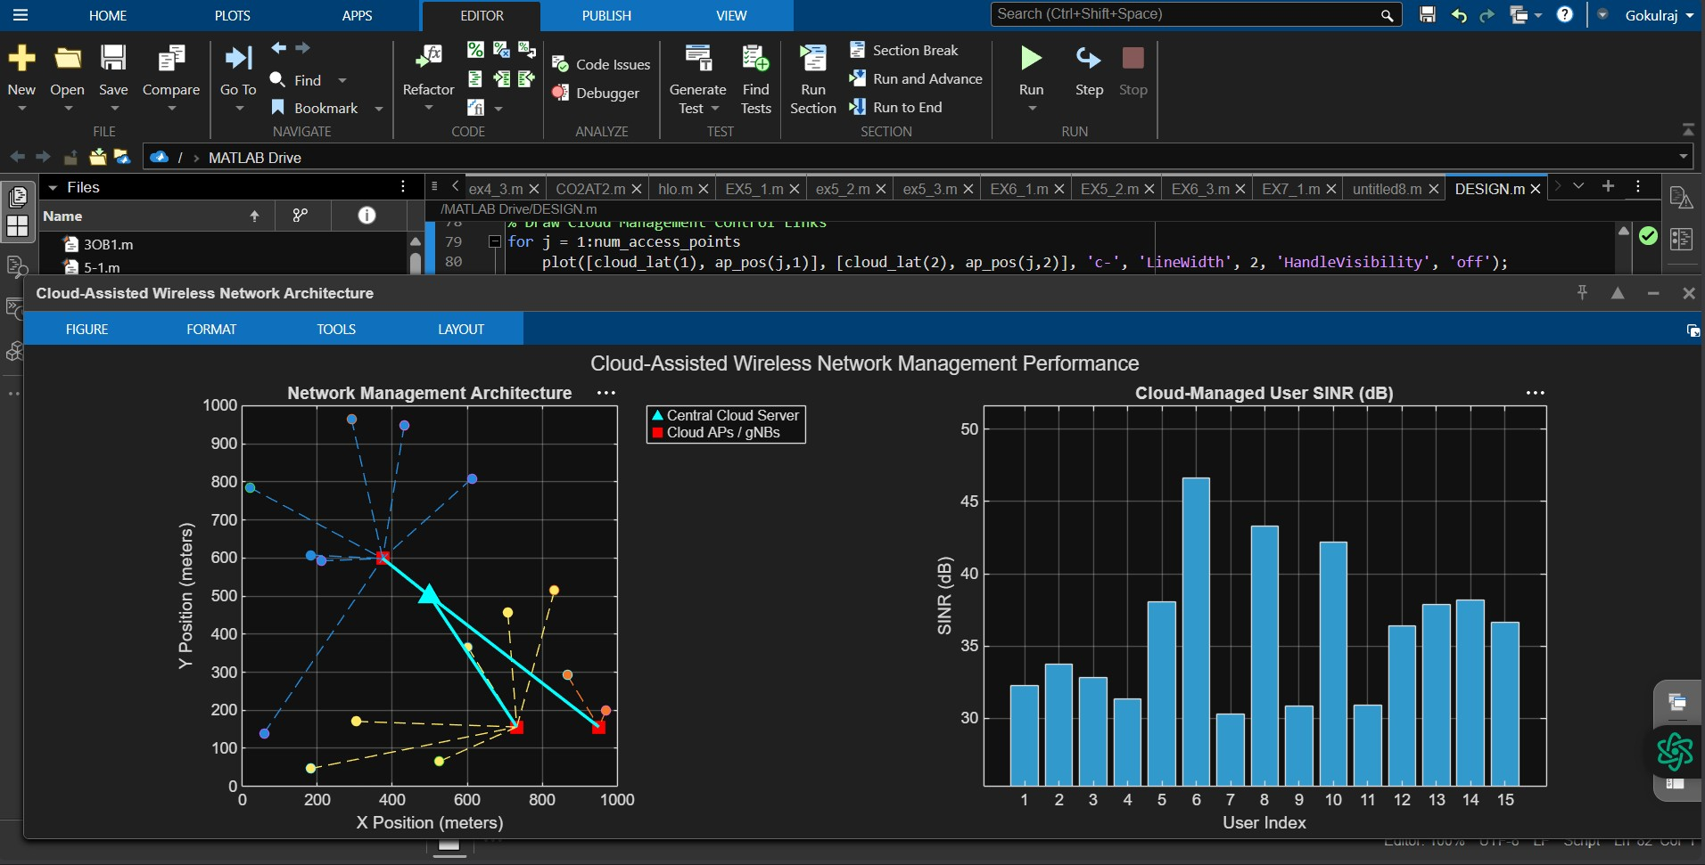
Explanation of MATLAB Output Plots:
The MATLAB simulation generates a two-panel visualization output titled "Cloud-Assisted Wireless Network Management Performance", which provides both spatial and quantitative insights into system behavior:
Left Panel: Network Management Architecture (Spatial Topology)
The left subplot illustrates the physical and operational layout of the 3-tier wireless network across a
1000m × 1000m deployment area. At the center of the grid sits a cyan triangle, representing the Central Cloud Server located at coordinates (500,500). High-capacity, low-latency backhaul control links are depicted as solid cyan lines connecting this central cloud directly to three distributed Cloud Access Points (APs / gNBs), shown as red squares. Scattered across the map are 15 user devices, represented by colored circular markers. The colored dashed lines linking each user to a specific red AP represent active wireless connection links. The central cloud server processes global channel state information and distance calculations to dynamically pair each user with the optimal AP that minimizes path loss, ensuring balanced load distribution across base stations.
Right Panel: Cloud-Managed User SINR (Performance Analysis)
The right subplot presents a bar graph evaluating signal quality across all 15 users via the Signal-toInterference-plus-Noise Ratio (SINR in dB). Each bar corresponds to an individual user node, reflecting the performance of the cloud server's centralized power control algorithm. The results show strong signal reliability across the entire network, with SINR values ranging from a minimum of 30.3 dB (User 7) to a peak of 46.7 dB (User 6). Taller bars highlight users positioned closer to their assigned access points, who benefit from lower path attenuation and minimal co-channel interference. Conversely, users located near cell boundaries experience slightly lower SINR due to higher interference from neighboring base stations. Overall, the consistent SINR levels across all nodes demonstrate that centralized cloud-based power control effectively mitigates inter-cell interference, ensuring robust throughput and link stability suitable for high-order modulation schemes.

Conclusion
The simulation and theoretical model confirm that a Cloud-Assisted Wireless Network Management Architecture significantly enhances network performance and resource efficiency in modern multi-user systems. By centralizing high-complexity control tasks—such as dynamic spectrum allocation, user association, and power control—at a central cloud server, the architecture offloads computational overhead from edge Access Points (APs/gNBs) while maintaining full control over inter-cell interference.
The MATLAB simulation results validate this approach:
- Effective Coverage & Association: Centralized path loss optimization ensures that all mobile users are associated with their optimal access point, maximizing received signal strength.
- Interference Mitigation & High SINR: Centralized power allocation successfully mitigates co-channel interference across neighboring base stations, maintaining high Signal-to-Interference-plus-Noise Ratio (SINR) levels across all user nodes (ranging between 30.3 dB and 46.7 dB).
- Scalability: The 3-tier framework provides a scalable foundation for next-generation (5G/6G) ultradense deployments, enabling high-order modulation schemes and reliable low-latency wireless communication.

